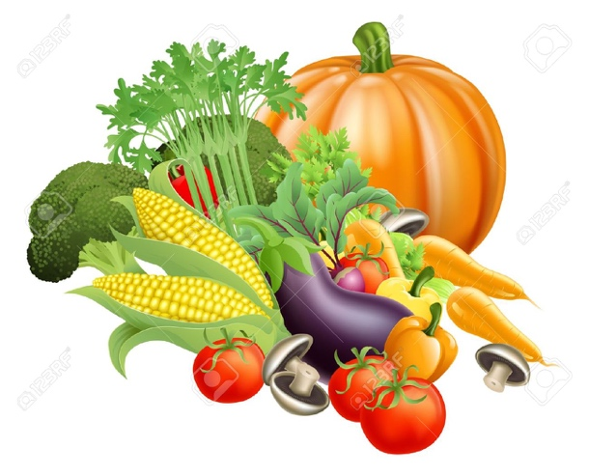
Schneider Shineman Community Garden
Newsletter
August 2026

Late summer is upon us; inspiring the springtime enthusiasm can be challenging. We continue to initiate new activities in the garden that help to keep interest alive.

- First, if you have been in the garden recently, you will have noticed the Library thanks to Sally Wise. Please feel free to contribute and borrow materials. You will find copies of the current and past newsletters. We will also have flyers from Cornell Cooperative Extension. We encourage you to add gardening books, recipes, seed packets or any other information you wish to share with the gardening community.

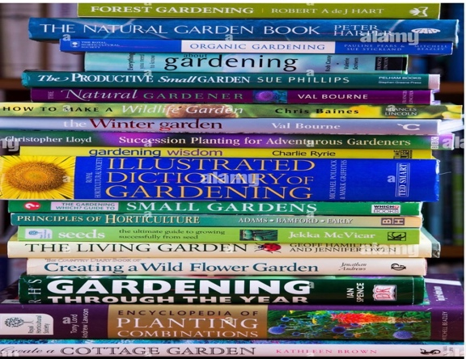

- Josh Vrooman, of Cornell cooperative Extension, has offered a program on growing and using herbs. The presenter is Julia Kinsey. The class is scheduled for Saturday, September 26 at 10:00 – 11:30 A.M. in our garden. ( in the church if it’s raining) Feel free to bring a friend as the program is open to all.
You will be asked to register. I will send you the link as soon as it is available.

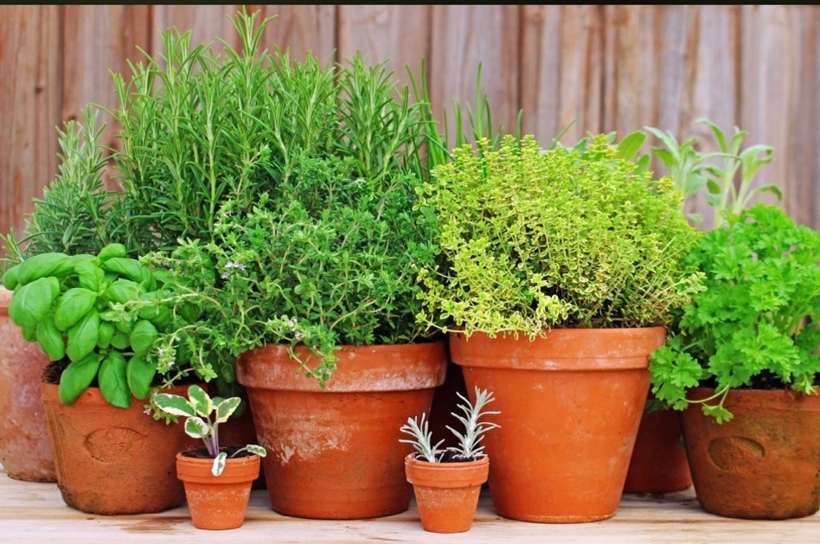

- Late summer planting: Crops like lettuce, spinach, kale and radishes can be planted now and will have time to mature to harvest before our growing season is over.
Here are a few tips:
- Yes, you can plant from seeds, but don’t delay.
- Water consistently.
- Keep weeds at bay. They can sap energy from your seedings.
- Harvest in a timely fashion.
- Clean garden bed as soon as plants are depleted.

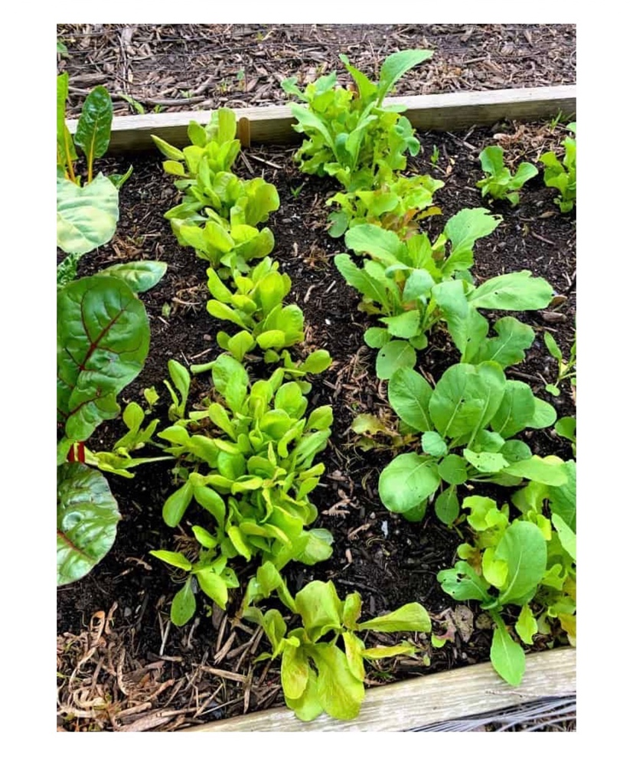
“Cultivate lasting friendships,
Sow seeds of kindness,
Listen to sage advice,
Don’t let little things bug you,
Be outstanding in your field,
Take thyme for yourself,
No vining (Whining)!”

Webpage
Don’t forget to check our webpage for photos and new info
www.gratitudeunited.com
The page is also accessible on Facebook.

Please contact a Board member if you have a concern or an idea to improve our garden:
Rocky Farden 315 272 7805
MaryAnn Donoghue 315 529 0167
Jan Herbert 315 529 0991
David King 315 343 2342
Hubert Parrow 725 251 0468
Barbara Wall 845 764 2877

See you in the garden,
Rocky

